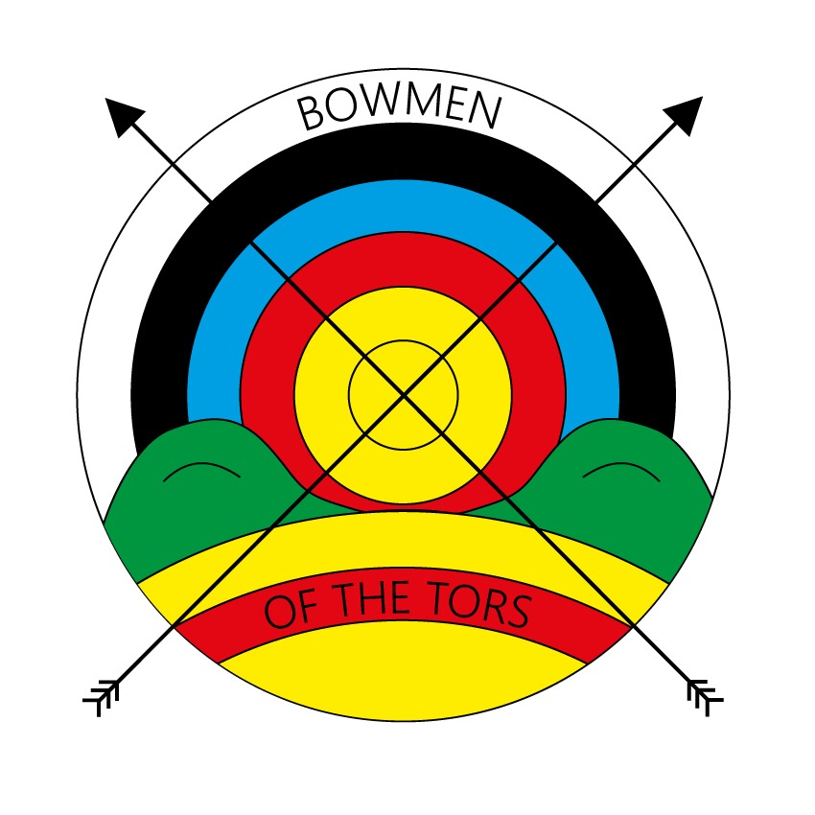
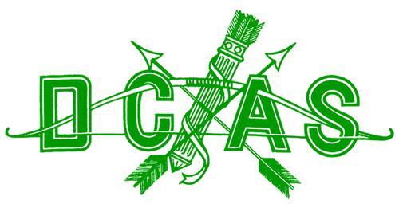
DEVON AND CORNWALL ARCHERY SOCIETY AUTUMN GOLD
Sunday 4 September 2022
___________________________________________________________________________
Rounds St George, Albion, Windsor, Windsor 50, Windsor 40 & Windsor 30

There will be 4 archers per target shooting in 2 details. Arrows will be shot in ends of 6 within 4 minutes.

Awards DCAS Gentlemen trophies - Recurve/Compound/Longbow/Barebow for St George round
DCAS Ladies trophies - Recurve/Compound/Longbow/Barebow for Albion round.
DCAS Junior awards (according to entries).
Medals awarded in all rounds/bow styles as follows:
1st – 1 Archer; 2nd – 4 Archers; 3rd – 7 or more archers.
Visitor Medals in all bow styles and rounds.
_______________________________________________________________________________________________
Lady Paramount/Lord Patron Chris Vitali
Judges Steve Allen, Phillip Rees
_______________________________________________________________________________________________
Hosted by Bowmen of the Tors Archery Club
Venue Notre Dame RC School, Looseleigh Lane, Plymouth, Devon PL6 5HN

Start time Registration from 9.00am; Assembly at 9.45am with sighters immediately after

Entry fees Seniors - £10.00 / Juniors - £5.00 (DCAS Juniors entry free this year)
Entries only accepted with correct fee. Payment may be made by cheque, cash or bank transfer (details on the Entry Form). Email, online and telephone entries will not be deemed confirmed until payment has been received.
Refunds will be at the discretion of the Tournament Organiser, but no refunds will be made after the closing date. Late entries will only be considered at the discretion of the Tournament Organiser.
Please indicate on the entry form if you are visually impaired, shoot from a wheelchair or have other specific requirements.
Only members of Archery GB or World Archery Federation are permitted to shoot at this tournament. Membership cards must be shown at Registration.

Closing date Wednesday 24 August 2022

Entries to Jennifer Ballard, 100 Townshend Ave, Keyham, Plymouth PL2 1PB
Email: TO@bowmenofthetors.co.uk Tel: 07901 693785

Dress Archers must comply with Archery GB rule 307.
Refreshments Refreshments will be available throughout the day.
Photography In view of the provisions of the Archery GB Protection of Children and Vulnerable Adults Policy those who wish to take photographs at the event should register with the Tournament Organiser.
Target list A draft Target List will be sent to entrants by email after the closing date, but please check the Target List on the day for any changes.
Liability The Devon and Cornwall Archery Society, Bowmen of the Tors and their members cannot accept responsibility for injury or any loss from or damage to vehicles or property left on the grounds.
DEVON AND CORNWALL ARCHERY SOCIETY – AUTUMN GOLD
Hosted by Bowmen of the Tors at Notre Dame RC School, Looseleigh Lane, Plymouth, Devon PL6 5HN
SUNDAY 4 SEPTEMBER 2022

Title: | Mr/Mrs/Miss/Master/Ms/Other
Name:

Address:
(incl postcode)
Tel: | Home |  |  |  |  | Mob
Email:

Club: |  |  |  |  |  |  |  | RH / LH
Archery GB No: |  |  |  |  |  | County: DCAS / Other
Recurve | Compound |  |  |  | Longbow | Barebow |  | Other
Colours: | Fletchings |  |  |  |  | Nocks
Rounds – please circle round entered
St George |  |  |  | Albion |  |  | Windsor
Windsor 50 |  |  |  | Windsor 40 |  |  | Windsor 30
Junior details: |  | DOB / Age on day |  |  |  | Shoot as senior Yes/No
Entry Fee enclosed |  | £ |  |  |  | Please make cheques payable to  “Bowmen of the Tors Archery Club”
 |  | ☐ or by BACS |  |  |  | Bank: Barclays Bank plc  Sort code: 20-67-19 A/c no: 93529274  A/c name: Bowmen of the Tors Archery Club  (quoting “Gold” and your name in the Reference)
I am a member of Archery GB/World Archery  Please indicate if you are signing to give permission for the entry of a Junior archer |  |  |  |  |  | Signature  (archer / parent / guardian) [please circle]
Disabled archers please state needs: |  |  | Wheelchair/Stool User Yes/No  Are you able to move on and off the line in time allowed? Yes/No  Are going to bring an assistant/agent? Yes/No
Able-bodied archers please tick if you are NOT prepared to collect and score for disabled archers ☐

ENTRIES TO Jennifer Ballard (Tournament Organiser), 100 Townshend Ave, Keyham, Plymouth PL2 1PB
Email: TO@bowmenofthetors.co.uk Tel: 07901 693785

Please note: When you enter this competition, the following information may be collected and shared with tournament organisers, scoring systems and other competitors eg via target lists and results published: first name, surname, gender, bow style, date of birth/age category, Club (and ID), County (and ID), Region (and ID), round (unless defined by age), disabled (Y/N) and disability information. By signing the entry form you are agreeing to this.

